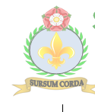
OCEANS KNOWLEDGE ORGANISER – Class 6
World Map and Overview |  |  | Interesting Features
The surface of the planet is 71% water. It contains 5 oceans: The Arctic, Atlantic, Indian, Pacific and Southern Oceans.  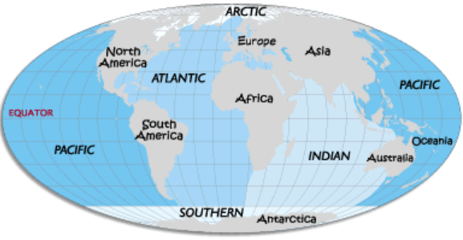  -The different oceans are shown by the different shades of blue on the map.  -All of the oceans are actually connected together.  -Because the oceans are so large, people sometimes break them down into even more categories, e.g. the ‘Northern Atlantic’ and the ‘Southern Atlantic.’  -The word ‘ocean’ comes from Greek, meaning ‘great stream.’ |  |  | Mariana Trench | 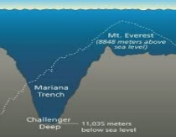 | The Mariana Trench is the deepest part of the Ocean. Its very deepest point, the Challenger Deep, is 10,971 metres deep! Even though it is very deep, a few people have visited it in submarines! |  |  | Where?  Pacific Ocean, near the island of Guam.
 |  |  | Hawaiian Islands | 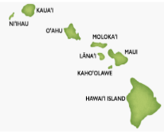 | The Hawaiian Islands are a series of eight islands in the Pacific Ocean. Even though they are a long way from the mainland, the islands are a state of the USA. They contain several large volcanoes. |  |  | Where?  1500km across the Pacific Ocean.
 |  |  | Gulf Stream | 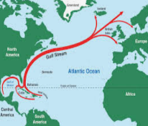 | The Gulf Stream is a huge, warm, ocean current that moves from the Gulf of Mexico to North America and Europe. It helps to keep these places from getting too cold in the winter time. |  |  | Where?  Atlantic Ocean, from central America northern to Europe.
 |  |  | Tides | 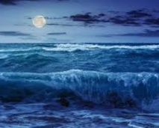 | Tides are the rise and fall of the levels of the ocean. They are caused by the pull of gravity from the Moon. Tides cycle as the Moon moves around the Earth. Therefore the oceans are always rising and falling. |  |  | Where?  All over the world, in all oceans!
 |  |  | North Pole | 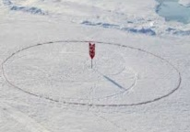 | The North Pole is actually a frozen part of the Arctic Ocean – there is no land beneath the ice! Because the ice keeps shifting on the ocean beneath, people keep having to move the flag that marks the Pole! |  |  | Where?  In the middle of the Arctic Ocean.
The Five Oceans
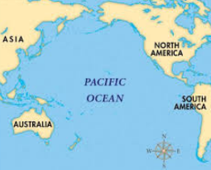
Pacific Ocean

-The Pacific Ocean is the largest ocean in the world. It covers nearly one-third (30%) of the Earth’s surface. It separates Australia and Asia from North and South America.

-The name Pacific Ocean means the ‘peaceful sea’ in Portuguese.

-Some of the main features in the Pacific Ocean include the Mariana Trench and the Hawaiian Islands.
 |  |  | Top Ten Facts |  |  | KEY VOCABULARY
 |  |  | - The average depth of the ocean is about 3.7km deep!  - The Pacific Ocean contains about 25,000 different islands!  - Around 95% of life on Earth lives in the oceans.  - It is thought that we haven’t yet discovered millions of creatures that live in the oceans.  - The largest creature that has ever lived, the blue whale, lives in all of the world’s oceans.  - The longest mountain ranges in the world are underwater: the mid-Atlantic and the mid-Oceanic ridges.  - Over 70% of the oxygen in the world is released from the ocean.  - The Pacific Ocean is wider than the Moon!  - In fact, more people have been to the Moon than the bottom of the Mariana Trench!  - Without travelling in a specially-designed submarine, the pressure in the deep ocean would crush you in no time! |  |  | SCIENCE:  - Food chain, food web  - Predator, prey, producer, consumer  - Evaporation, condensation  - Sieving, filtration  GEOGRAPHY:  - Sustainability, pollution, environment, micro-plastics  - Surface, ocean, depth, habitat, inhabitants, ecosystem, ecology  - Northern/Southern hemisphere, Tropic of Cancer/Capricorn, Arctic/Antarctic circle
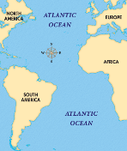  Atlantic Ocean  -The Atlantic Ocean is the second largest ocean in the world. It covers about 20% of the earth’s surface.  -It separates North and South America from Europe and Africa. It contains the Gulf Stream. | 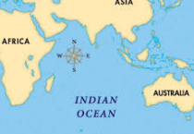  Indian Ocean  -The Indian Ocean is the third-largest ocean in the world. It is the warmest ocean in the world!  -It lies south of India and separates Australia from Africa. It contains Madagascar and Sri Lanka.
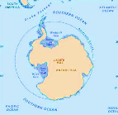  Southern Ocean  -The Southern Ocean is the second smallest ocean. It is in the southernmost part of the world - around Antarctica.  -As it is so far south, much of the Southern Ocean is normally covered in ice (like the Arctic Ocean). | 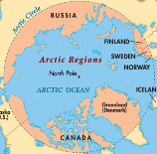  Arctic Ocean  -The Arctic Ocean is the smallest and shallowest of the world’s oceans. It is in the northernmost part of the world.  -For much of the year, the Arctic Ocean is covered by ice. It has lots of fresh water, from melting ice.

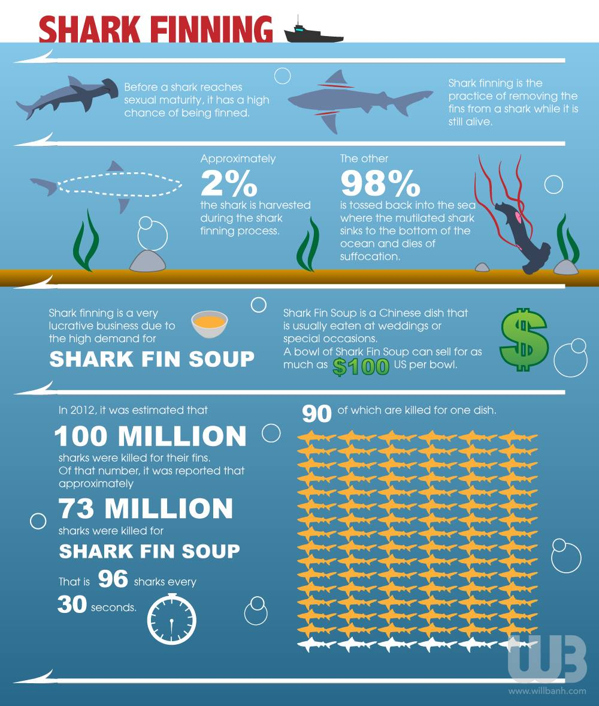
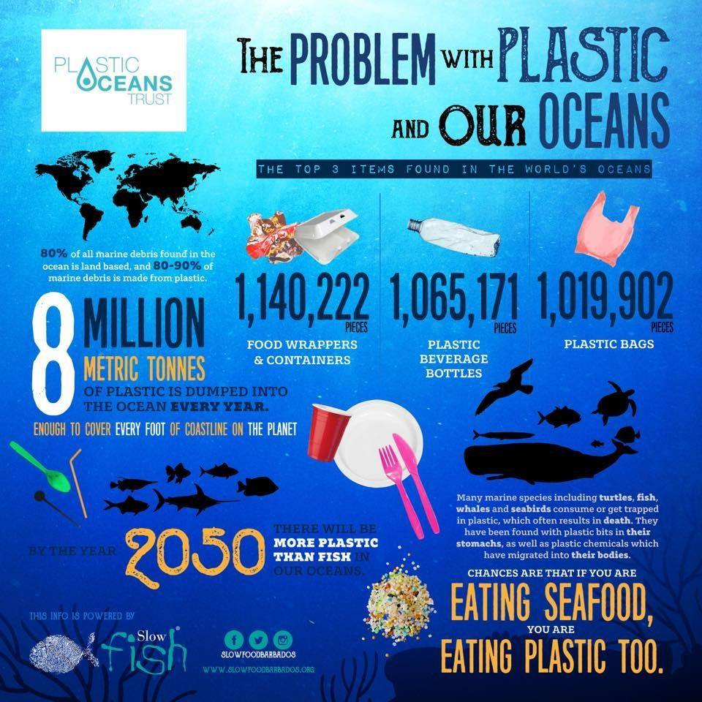
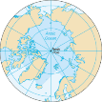
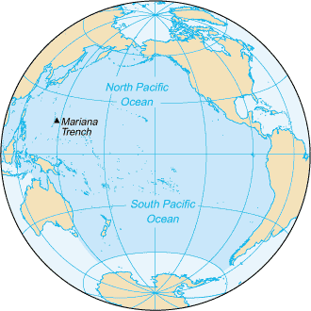
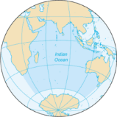
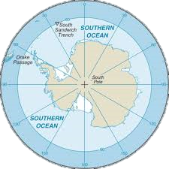
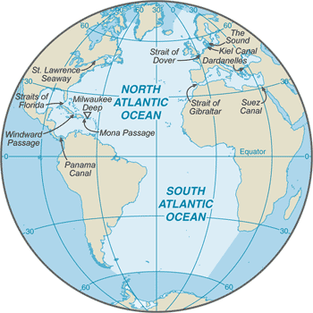
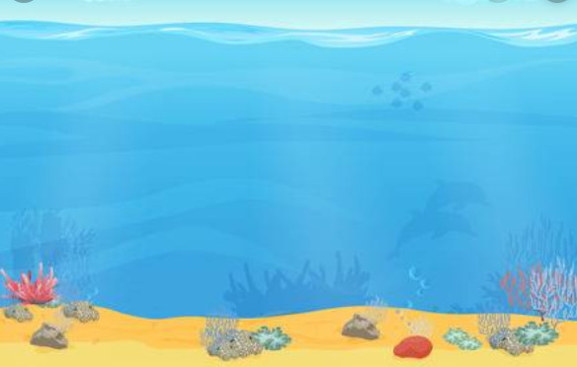
ENVIRONMENTAL ISSUES
Oceans by Size
Pacific – 161.8 million km²
Atlantic – 106.5 million km² km²
Indian – 70.5 million km² km²
Southern – 20.3 million km² km²
Arctic – 14 million km² km²
Kuril-Kamatcha Trench – 10.4km
Tonga Trench – 10.9km
Mariana Trench – 11km
Deepest Points
Philippine Trench – 10.5km

