Online links to learning and fun for ages 3-5

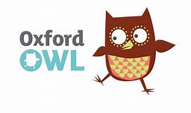 | https://www.oxfordowl.co.uk/for-home/find-a-book/library-page/?view=image&query=&type=book&age_group=&level=&level_select=&book_type=&series=#  Free online reading library
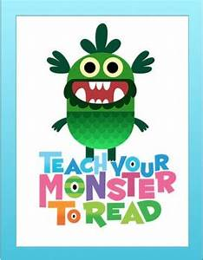 | https://www.teachyourmonstertoread.com/  Phonics games
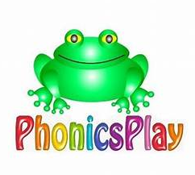 | https://new.phonicsplay.co.uk/  Username: march20  Password: home  Click on Phase 1 or Phase 2 resources
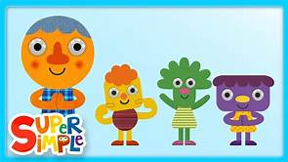 | https://supersimple.com/super-simple-songs/  Popular songs and nursery rhymes enjoyed at school
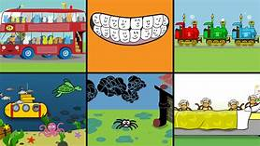 | https://www.bbc.co.uk/teach/school-radio/nursery-rhymes-songs-index/zhwdgwx  Animated nursery rhymes
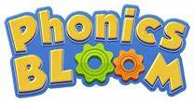 | https://www.phonicsbloom.com/uk/game/list/phonics-games-phase-1  https://www.phonicsbloom.com/uk/game/list/phonics-games-phase-2  Phonics games
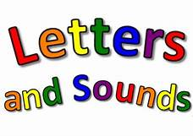 | http://www.letters-and-sounds.com/phase-1-games.html  http://www.letters-and-sounds.com/phase-2-games.html  Phonics games
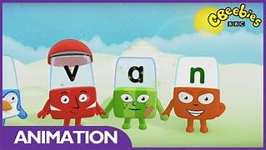 | https://www.bbc.co.uk/iplayer/episodes/b01cz0p1/alphablocks  Alphablocks episodes
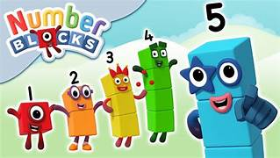 | https://www.bbc.co.uk/iplayer/group/b08bzfnh  Numberblocks episodes
https://www.topmarks.co.uk/english-games/3-5-years/letters-and-sounds

https://www.topmarks.co.uk/maths-games/3-5-years/counting

Online games
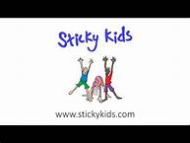 | https://www.youtube.com/watch?v=kSBSD_hYpVg&list=PLfcTZEc_3M1NMtEdx8uF-W2XnfP5c5PiR  Action songs
https://www.cosmickids.com/category/watch/

Yoga stories and action songs

https://bookflix.digital.scholastic.com/home?authCtx=U.642726498

Explore the world of reading

