YEAR 5
Majestic Monarchs
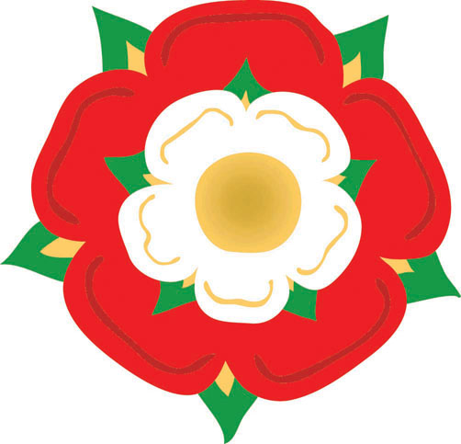

Autumn Term 2015
Homework Project Booklet

Introduction

This term you will have a choice of tasks, mostly linked to your topic, which are outlined in this booklet!
You may choose which tasks to do, but you must continue to hand in your homework book weekly on a Wednesday for checking progress and marking.
The activities are organised by subject. To achieve a good balance over the term, the booklet shows the minimum number of tasks to be completed for each subject (for example, 5 of the English activities should be completed)
Maths
Maths homework must be completed weekly. The Year 5 maths objectives are listed in the back of the booklet. Some weeks your teacher will give you specific maths homework to complete. Otherwise, you must select an objective from the list in the booklet to practise, choosing your own way to present your work and challenge yourself.

English: choose at least 5 tasks

- Read daily! Write a response to your reading:
- Write a ‘blurb’ for the back cover
- Describe a favourite character
- Recount part of the story in your own way
- Write a letter to a character
- Write a book review
- Read to someone and ask them to write a comment
- Describe a setting in rich detail. Choose a setting from Tudor times e.g. in the Court of King Henry VIII, on the deck of the Mary Rose, at the public execution of Anne Boleyn…
- Write a poem about Henry VIII and/or his six wives. (Can you write it in a narrative style?)
- Write a non-chronological report entitled ‘Rich and Poor in Tudor times’ (or choose a different aspect of Tudor life)
- Write a glossary of Tudor words
- Write a diary entry based on the book King of Shadows
- Older literature: Ask a parent or grandparent to tell you about their favourite childhood book. What did they tell you? Write a summary of the story.

Science: choose at least 2 tasks

- Solids, liquids and gases: Find various (safe to handle) liquids around the kitchen. Put them in order of viscosity (stickiness) by observing how easily they pour! Predict beforehand
- Create a poster for display that explains the key differences between a solid, liquid and gas
- Earth, sun and moon: Keep a ‘moon diary’ for a month. Record the phases of the moon. Include photos if you can!
- Write a detailed fact file about a planet (or planets)

History: choose at least 1 task

- Create a timeline to show important events over the Tudor period
- What was the historical event ‘Field of the Cloth of Gold’? Present your findings in an interesting way.
- Write a character profile of a well-known Tudor figure e.g. Sir Walter Raleigh, Anne Boleyn

Geography: choose at least 1 task

- Show on your own outline map of the UK where the Battle of Bosworth took place. Label the nearest cities and any major rivers.
- On an outline map of the world, show the route taken by Sir Francis Drake on his famous voyage. Label some of the places he visited along the way.

Art / Design and Technology: choose at least 1 task

- Create your own Tudor emblem. Explain your design.
- Design a menu for a feast in the Court of King Henry VIII.
- Use a portrait photo of yourself (or a family member) and halve it vertically through the nose and forehead. Use sketching and shading techniques to draw the other half.

**A maths activity should be completed every week**
(refer to the introduction in this booklet)

Maths: Year 5 Key Objectives
Number and Place Value:
- Read, write, order and compare numbers to at least 1 000 000
- Count forwards or backwards in steps of multiples of 10 for any number up to 1 000 000
- Count forwards and backwards with negative numbers, including through zero
- Round a number to the nearest 10, 100, 1000, 10 000 and 100 000
- Read Roman numerals to 1000 (M) and recognise years written in Roman numerals

Addition and subtraction:
- Add and subtract whole numbers with more than 4 digits, in columns
- Add and subtract numbers mentally with increasingly large numbers
- Solve addition and subtraction multi-step problems

Multiplication and division:
- Identify multiples and factors (and common factors of two numbers)
- Work out if a number up to 100 is prime
- Multiply numbers up to 4 digits by a one- or two-digit number
- Divide numbers up to 4 digits by a one-digit number
- Multiply and divide numbers (and those involving decimals) by 10, 100 and 1000
- Use square numbers and cube numbers
- Solve problems involving multiplication and division

Number – Fractions (including decimals and percentages):
- Order fractions (where denominators are multiples of the same number) e.g. $\frac{2}{3}$ $\frac{7}{9}$ $\frac{5}{15}$
- Write equivalent fractions of a given fraction
- Recognise mixed numbers and improper fractions and convert from one form to the other
- Read and write decimal numbers as fractions. For example, 0.71 = $\frac{71}{100}$
- Round decimals with two decimal places to the nearest whole number and to one decimal place
- Order and compare numbers with up to three decimal places
- Write percentages as a fraction with denominator 100, and as a decimal
Measurement:
- Convert between different units of metric measure (e.g. cm and metre; gram and kilogram; litre and millilitre)
- Convert approximately between metric units and imperial units such as inches, pounds and pints
- Measure and calculate the area and perimeter of shapes in centimetres and metres
- Solve problems involving measure [for example, length, mass, volume, money] using decimal notation
Geometry:
- Identify a wide range of 3-D shapes
- Estimate and compare acute, obtuse and reflex angles
- Draw given angles, and measure them in degrees (°)
- Use the properties of rectangles to find missing lengths and angles
Statistics:
- Solve problems using information presented in a line graph
Complete, read and interpret information in tables, including timetables.

